Communications Earth & Environment

Supporting Information for
Complex rupture dynamics on an immature fault during the 2020 Mw 6.8 Elazığ earthquake, Turkey
František Gallovič^{1*}, Jiří Zahradník¹, Vladimír Plicka¹, Efthimios Sokos², Christos Evangelidis³, Ioannis Fountoulakis³, Fatih Turhan⁴
¹ Department of Geophysics, Faculty of Mathematics and Physics, Charles University, Prague, Czech Republic
² Department of Geology, Seismological Laboratory, University of Patras, Patras, Greece
³ Institute of Geodynamics, National Observatory of Athens, Athens, Greece
⁴ Kandilli Observatory and Earthquake Research Institute, Boğaziçi University, Istanbul, Turkey
*Corresponding author: František Gallovič (gallovic@karel.troja.mff.cuni.cz)

Table S1 – Picked onset times of the first weak P and second strong P’ phases on broadband (white rows) and strong-motion (grey rows) stations. For some broadband stations the P’ pick is missing because the onset was masked by preceding wave groups. The picks refer to time 17:55:00.

Station  code | Latitude  [°N] | Longitude  [°E] | Distance  [km] | Azimuth  [°] | P  [s] | P’  [s] | P’-P  [s]
ELZG | 38.4978 | 38.9844 | 17.9 | 328.8 | 15.05 | - | -
2308 | 38.4506 | 39.3102 | 21.7 | 62.2 | 15.53 | 17.56 | 2.03
4404 | 38.1959 | 38.8739 | 26.3 | 226.2 | 16.21 | 22.17 | 5.96
FRT | 38.6840 | 39.1976 | 37.2 | 14.5 | 17.95 | - | -
MDN | 38.3931 | 39.6821 | 51.8 | 85.7 | 20.32 | - | -
MAYA | 38.3253 | 38.4253 | 58.3 | 266.4 | 21.38 | 27.41 | 6.03
2104 | 38.2644 | 39.7590 | 59.4 | 100.0 | 22.22 | 25.32 | 3.10
NARI | 37.884 | 38.7612 | 60.2 | 208.7 | 22.46 | 28.18 | 5.72
4401 | 38.3496 | 38.3402 | 65.6 | 269.2 | 22.62 | 28.59 | 5.97
KOVA | 38.7057 | 39.8126 | 73.7 | 58.4 | 23.79 | - | -
KAH | 37.8053 | 38.6101 | 74.6 | 214.5 | 24.93 | 30.82 | 5.89
2307 | 38.6958 | 39.9320 | 82.3 | 62.8 | 25.11 | 28.37 | 3.26
2105 | 38.3581 | 40.0713 | 85.7 | 89.8 | 26.44 | 29.13 | 2.69
4407 | 38.7807 | 38.2641 | 85.8 | 303.2 | 26.01 | 31.34 | 5.33
6201 | 39.0747 | 39.5347 | 88.2 | 25.8 | 25.48 | 28.98 | 3.50
HANM | 37.5799 | 38.8805 | 88.5 | 192.1 | 27.21 | 32.82 | 5.61
2305 | 38.7278 | 40.1310 | 99.5 | 65.4 | 27.62 | 30.85 | 3.23
2101 | 37.9309 | 40.2028 | 108.5 | 115.6 | 29.92 | 33.37 | 3.45

Table S2 – Model and computational parameters considered in the dynamic inversion of the 2020 Elazığ earthquake.

Parameter | Value
General
Fault mechanism | Strike: 246°, dip: 80°, rake: 0°
Fault dimensions | Length 75 km, width 20 km
Fault top depth | 0 km
Normal stress depth gradient | 16.2 MPa/km
Cohesion | 0.5 MPa
FD3D
Spatial grid discretization | 0.2 km
FD half-domain grid size (along strike x normal x along-dip) | 375 x 50 x 100
Maximum duration of slip-rate functions | 25 s
Time step | 0.005 s
Green’s functions
Spatial fault discretization | 1.5 x 1.0 km
Time sampling | 0.4 s
Waveform frequency range (displacements) | 0.05 – 0.30 Hz  (2301, 2302, 2308, 4401, 4404)  0.05 – 0.15 Hz (other stations)
Model parameterization and prior parameter ranges (homogeneous along the fault)
Control point grid (along-strike x along-dip) | 31 x 19
Initial stress prior | 0 – 1 GPa
Static-to-dynamic friction coefficient drop prior | 0 – 5
Characteristic slip-weakening distance prior | 0.2 – 5.0 m
Nucleation area prior (along-strike, up-dip, radius) | 25 km, 5 km, 5 km
Maximum mean overstress in the nucleation area | 2 MPa

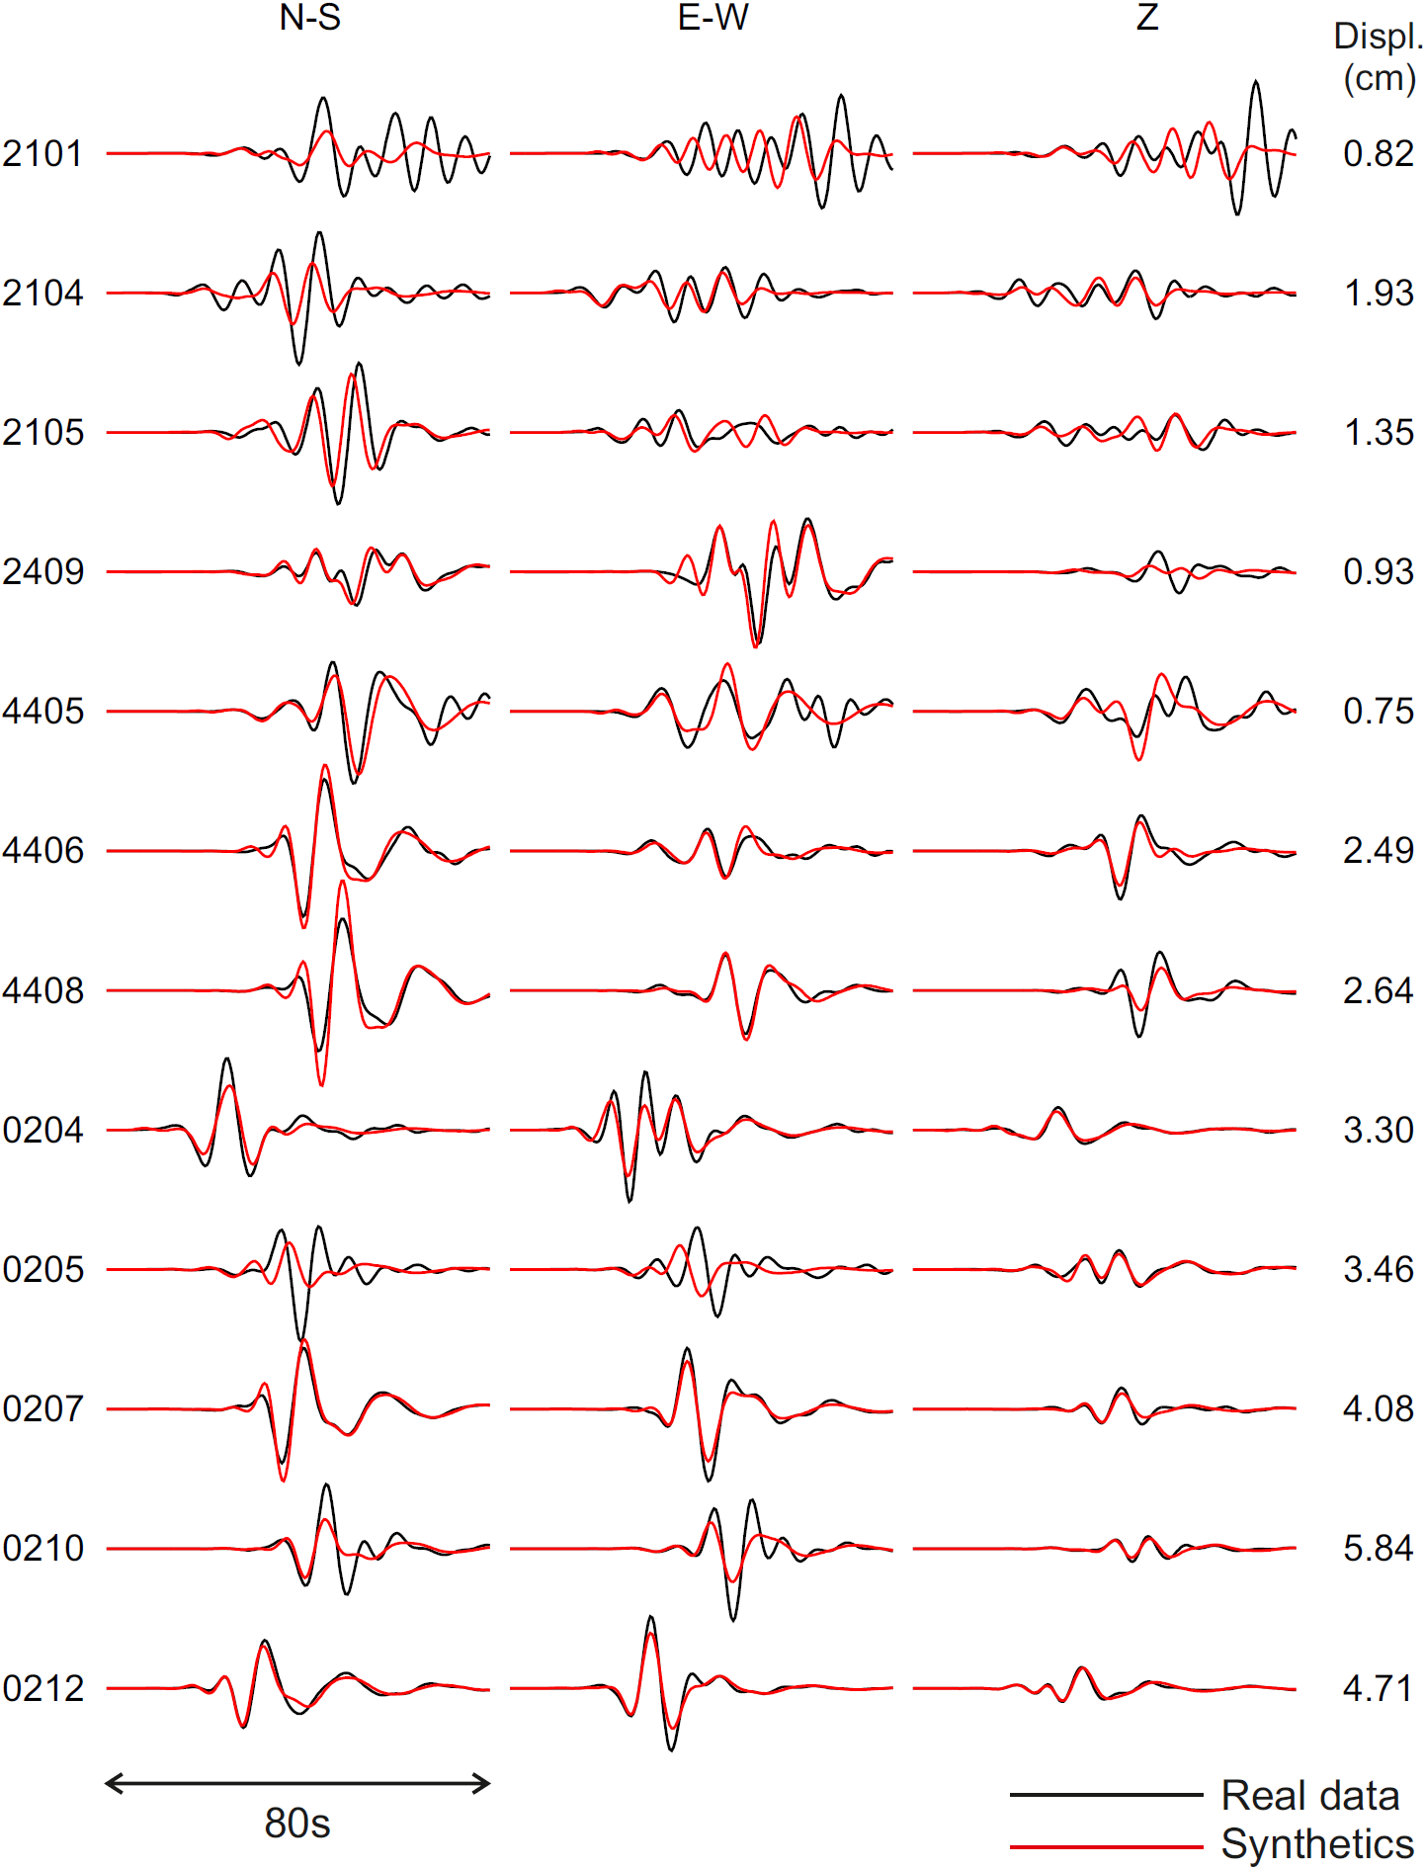

Figure S1. Prediction of displacement waveforms by the MAP dynamic source model from the main text. For the station positions, see Figure 2. Note station 0205 seems to have an incorrect orientation of the horizontal components.

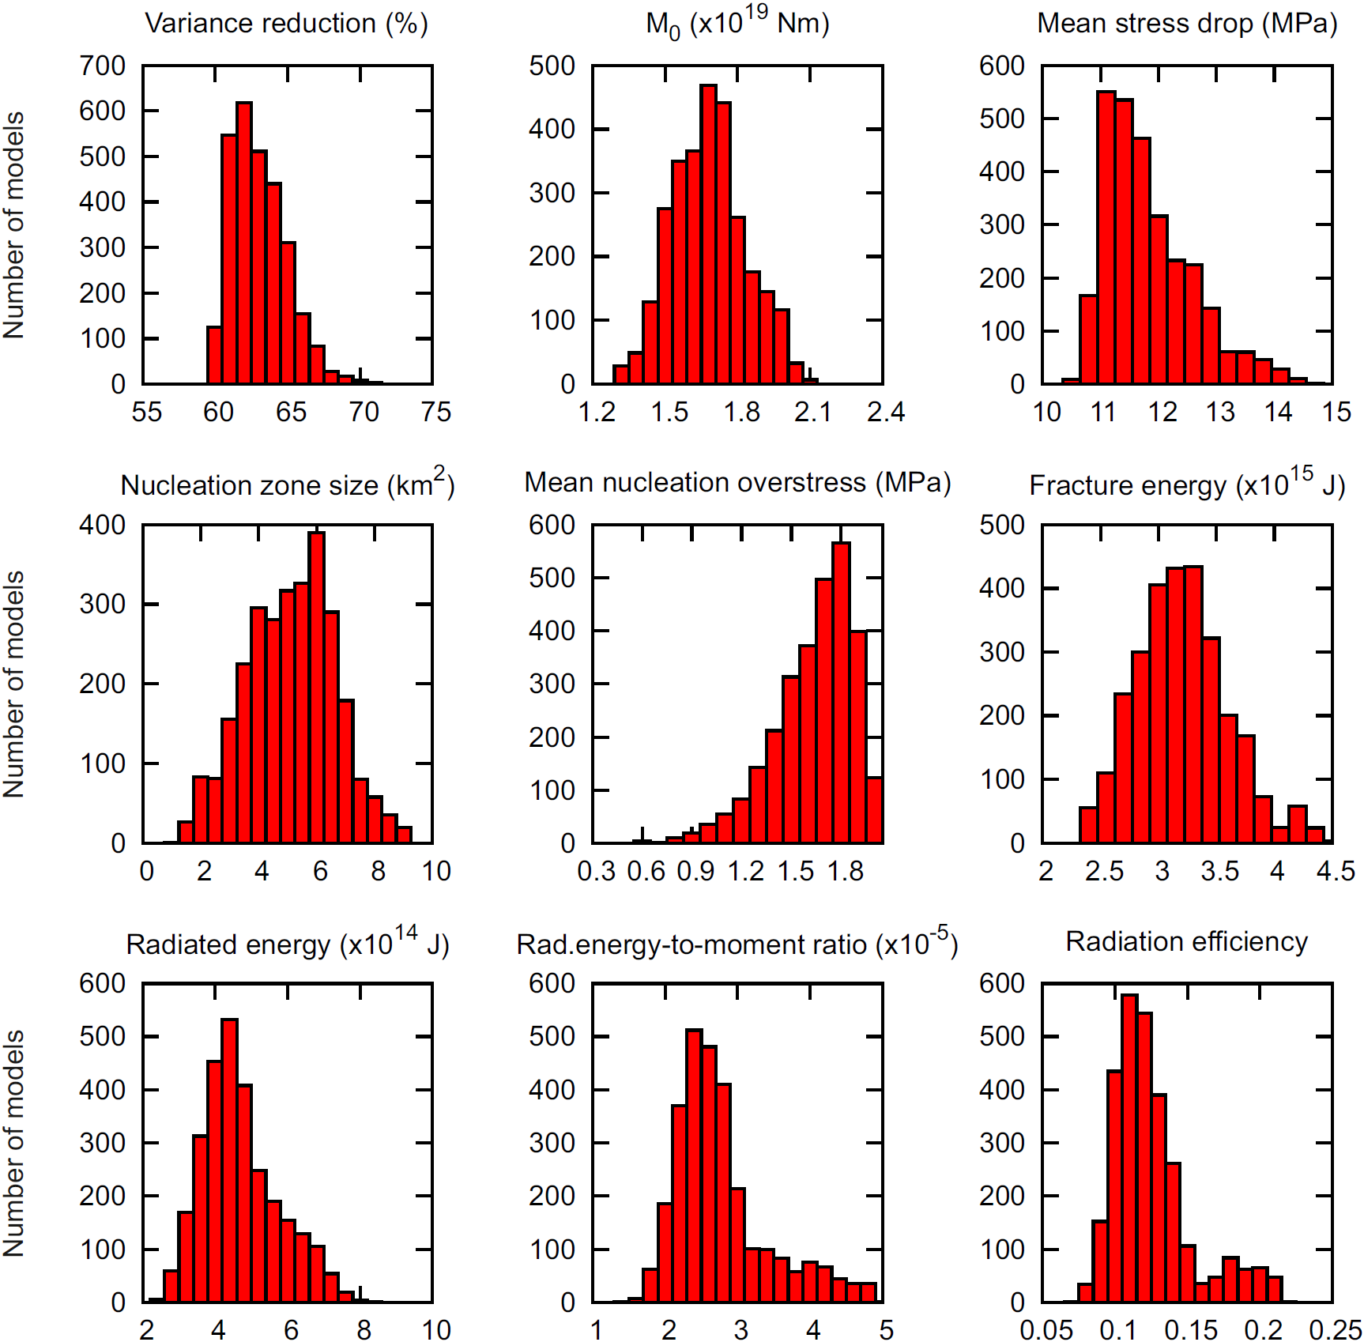

Figure S2. Histograms of rupture parameters. The individual parameters (see panel titles) as inferred by our Bayesian inversion considering models within 2% of the posterior probability density function maximum (accepted models).

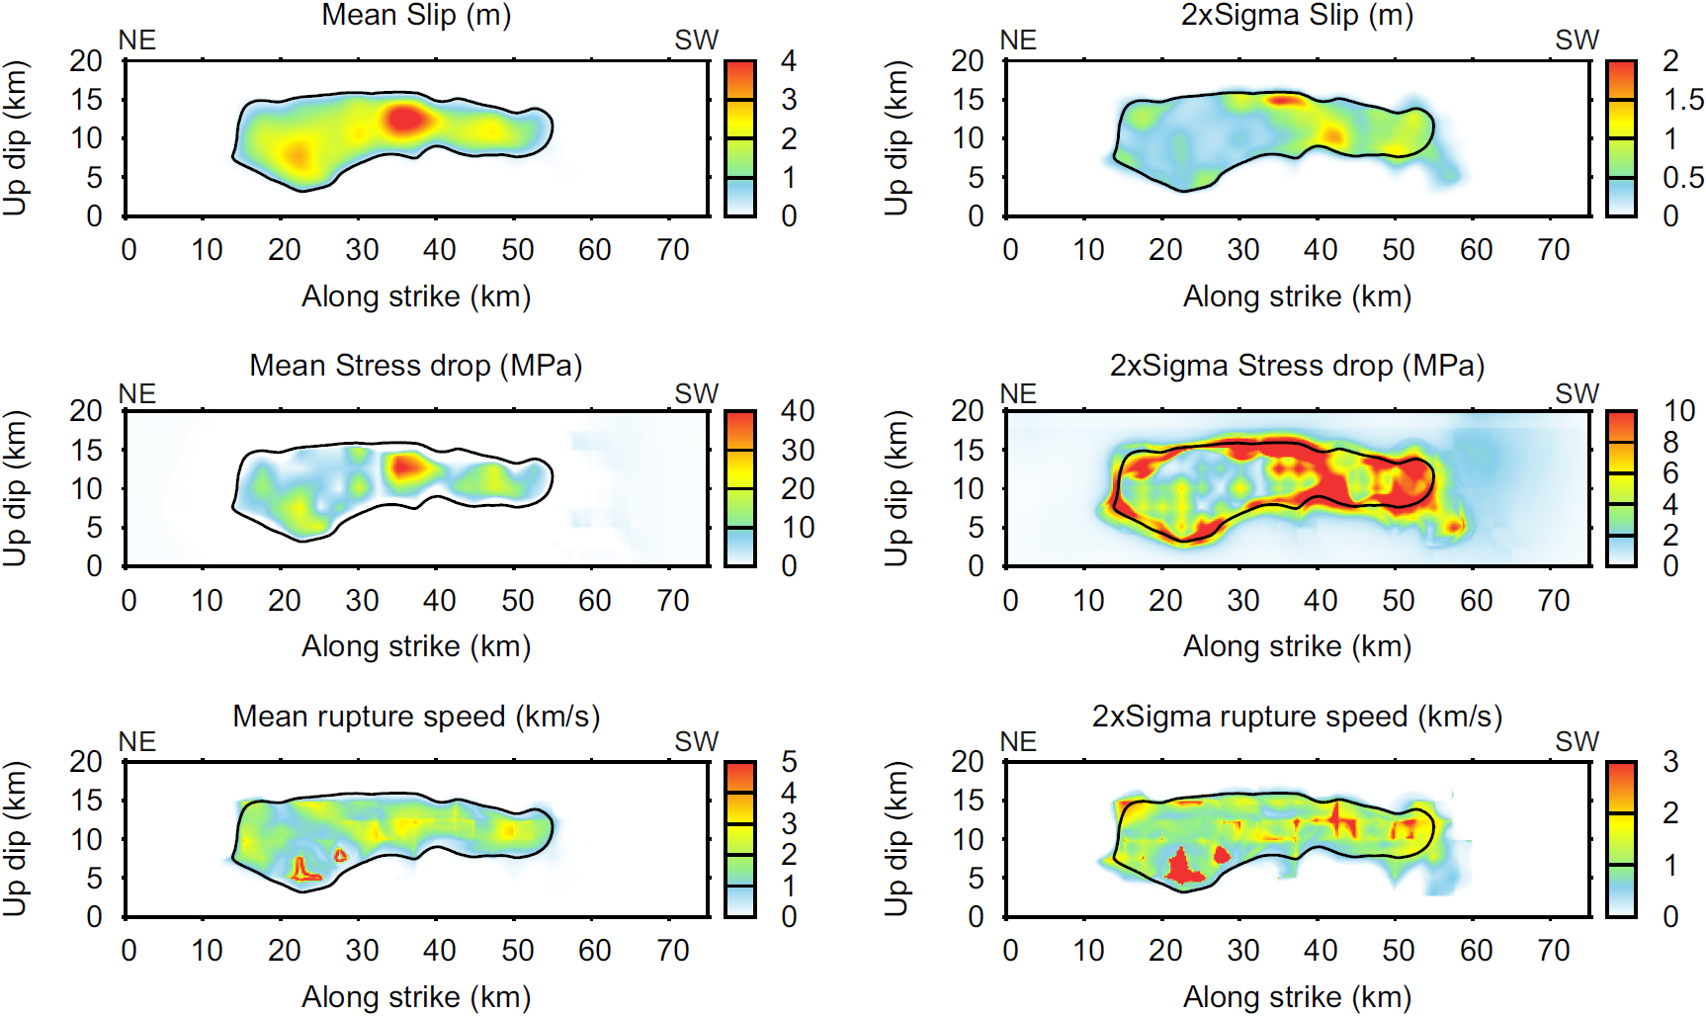

Figure S3. Mean and uncertainty of the inferred kinematic parameters. The individual parameters (see panel titles) have been calculated as ensemble average (left) and ensemble standard deviation (right) over the accepted posterior samples. Black contour delineates the ensemble average of the slip distribution.

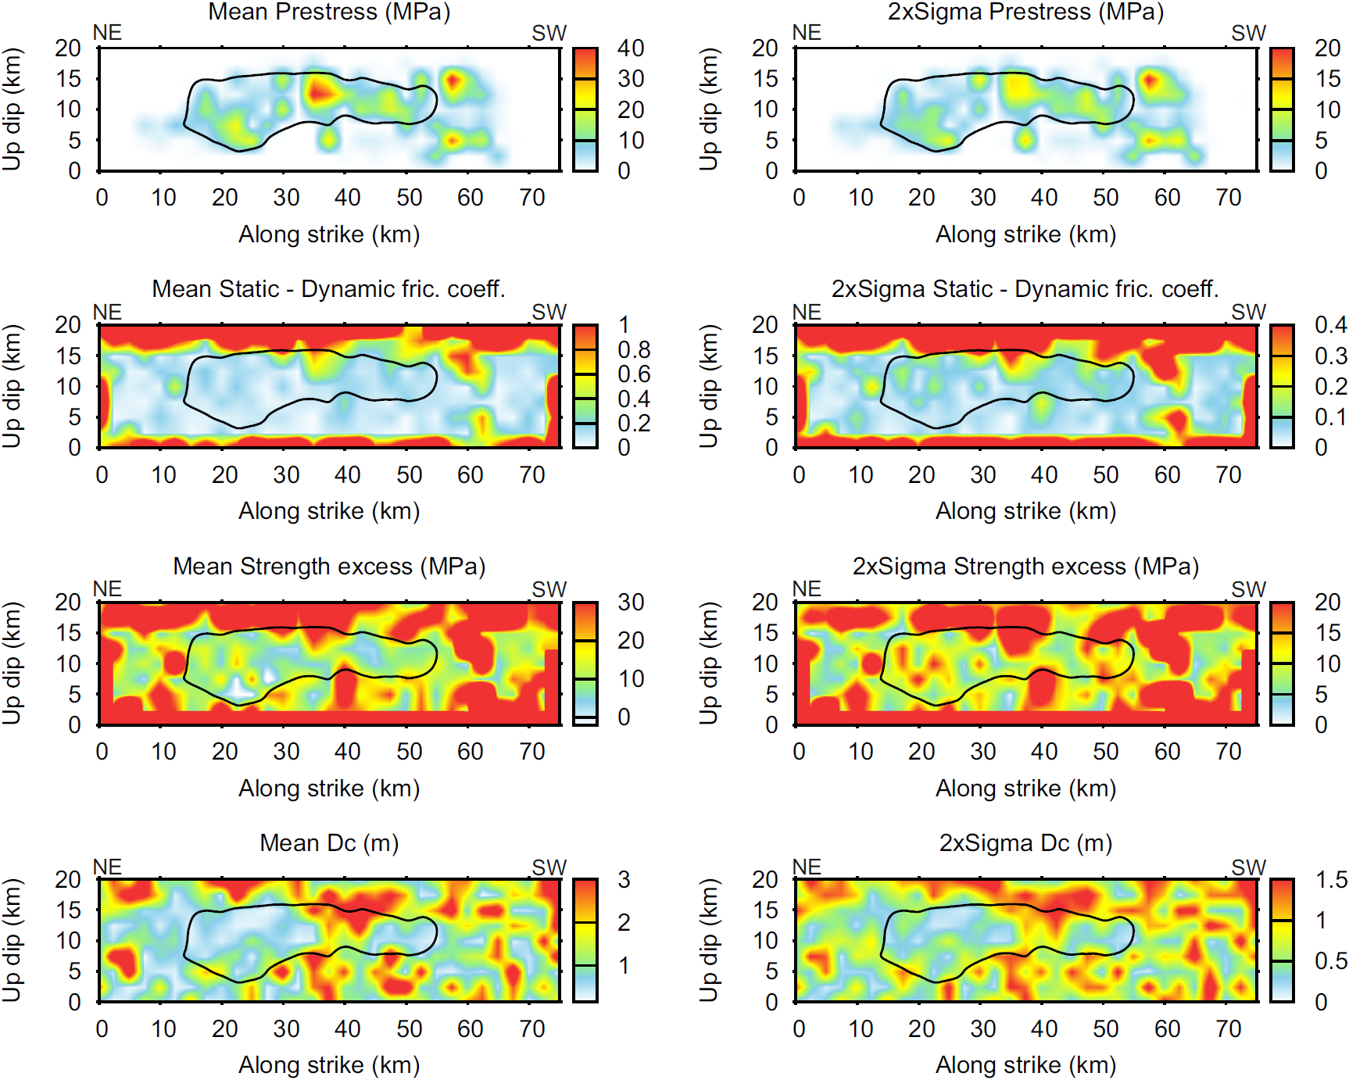

Figure S4. Mean and uncertainty of the inferred dynamic parameters. The individual parameters (see panel titles) have been calculated as ensemble averages (left) and ensemble standard deviations (right) over the accepted posterior samples. Black contour delineates the ensemble average of the slip distribution.

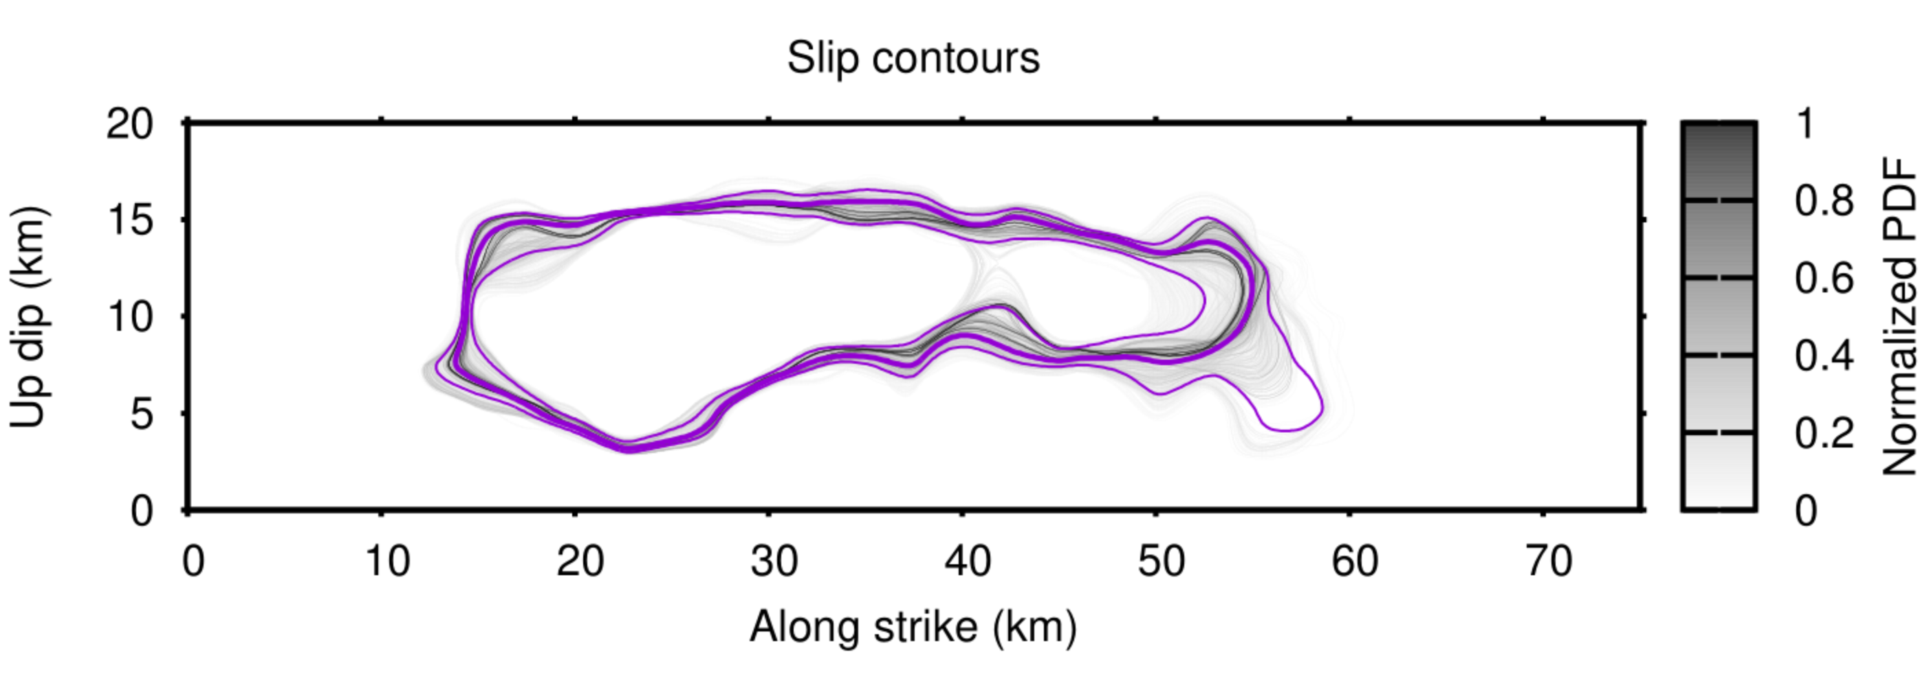

Figure S5. Uncertainty of ruptured area from the Bayesian dynamic source inversion. Slip contours of all posterior model samples within 2% of the posterior probability density function maximum (gray coded), displaying the variability of the inferred spatial rupture extent. The thick and thin magenta lines show slip contours of an ensemble average and its ±2σ uncertainty. Note the large variability of the end of the rupture in the along-strike direction, suggesting unconstrained final length of the rupture.

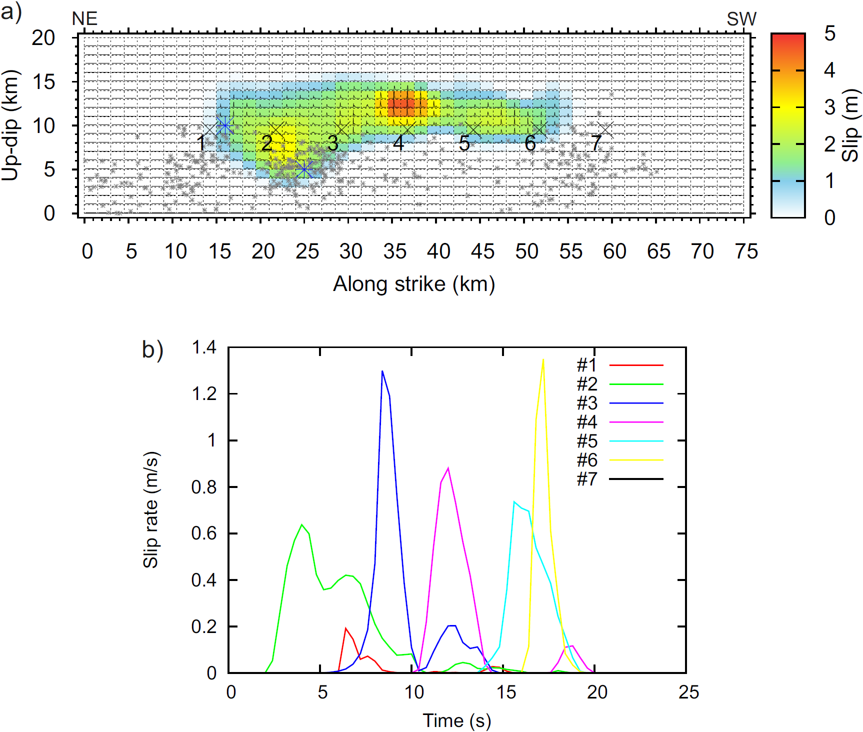

Figure S6. The MAP dynamic inversion model from the main text. a) Slip on the fault, with slip-rate functions (small insets), relocated aftershocks (gray asterisks) and hypocenters H and H’ (blue asterisks near the along-strike 25 km and 15 km, respectively). b) Slip rate functions zoomed from seven points marked in panel a) by black crosses. Note that multiple maxima of some slip rates are due to re-rupturing of the respective part of the fault.

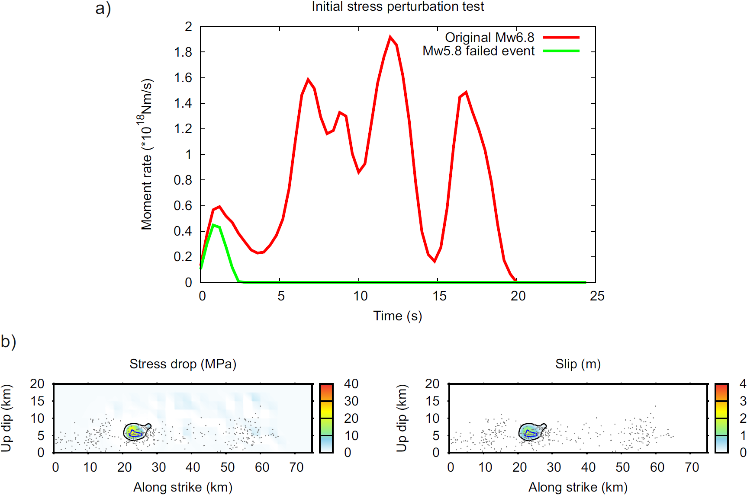

Figure S7. Dynamic rupture simulation of a failed earthquake initiation. Decreasing the initial stress of the MAP dynamic model by 10% in the top 12 km above the nucleation (keeping the other parameters fixed) leads to a rupture that fails to develop into the full Mw 6.8 event. Instead, an Mw 5.8 event happened, suggesting that the previous seismicity (Supplementary Figure S8) could be understood as failed nucleations of events that would rupture the whole segment under suitable (stress) conditions. a) Moment rate function of the failed event (green) in comparison with that of the MAP model (red). b) Stress drop and slip of the failed event. The black and blue contours outline the slip and nucleation patch, respectively.

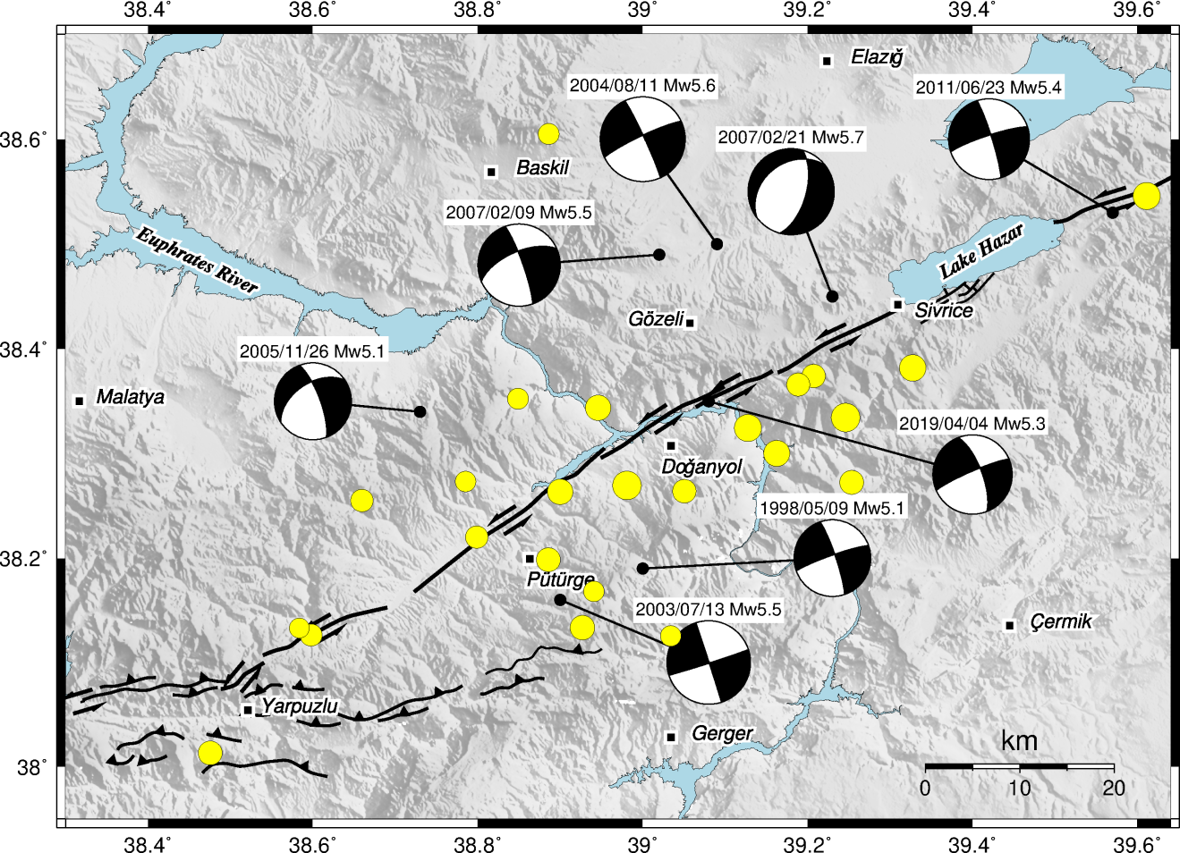

Figure S8. Instrumental seismicity of the region. Shown by beachballs are all existing GCMT focal mechanisms (since 1976) of the Mw>5 earthquakes. Shown by yellow circles are all existing events of the International Seismological Center catalogue (since 1964) of Mw>4; they include the 8 GCMT events but their epicenter positions are slightly different.

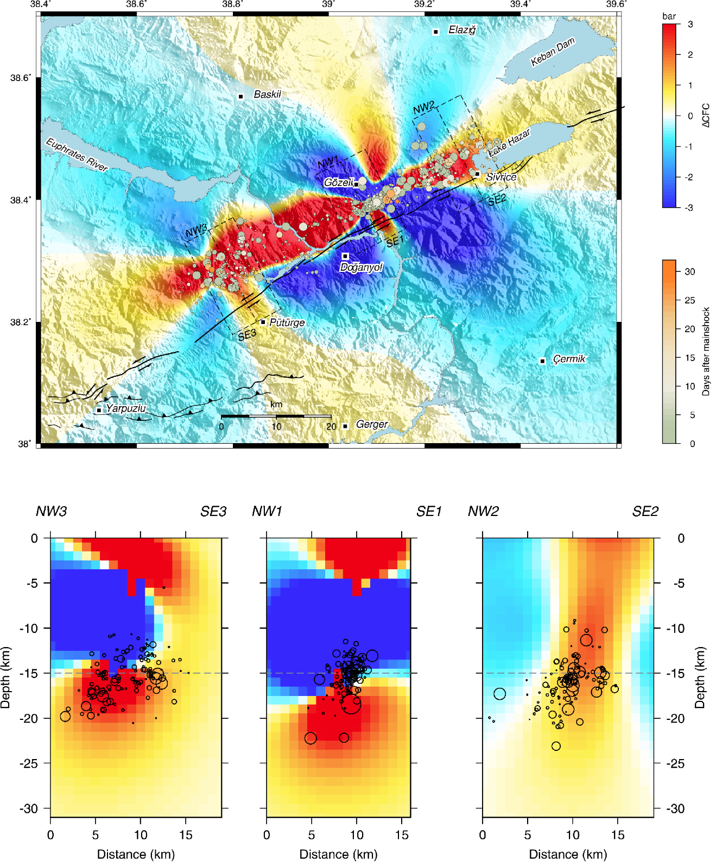

Figure S9. Coulomb stress change due to the slip-distribution of the MAP dynamic model. Receiver faults have the mechanism of the mainshock. a) The map view of the CSC at a depth of 15 km. b) The vertical cross sections along the three profiles shown in panel a).

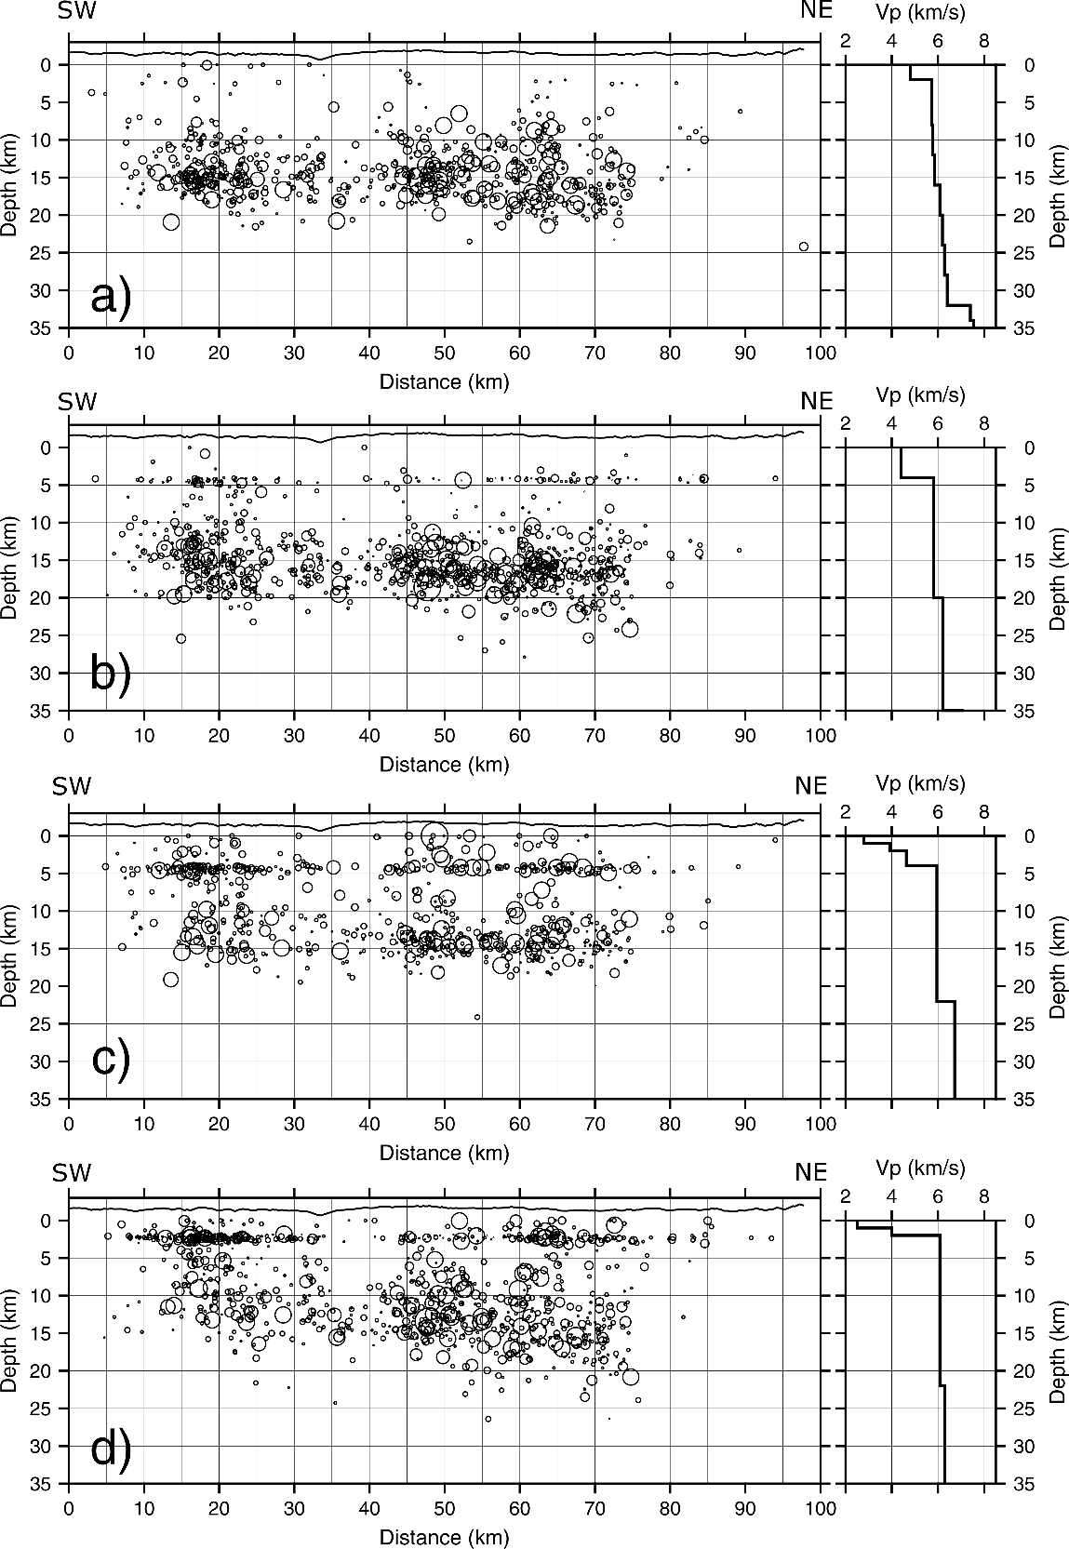

Figure S10. Locating the Elazig sequence along the East Anatolian Fault. Effect of the velocity model is demonstrated for four cases: a) VM1 (Acarel et al., 2019), b) VM2 (Maden, 2012), c) VM3 (Gallovič et al., 2013) d) VM4 (Pasyanos et al., 2004). To the right of the sections are the respective velocity models. Root means square residuals for the individual models are RMS_VM1=0.21s, RMS_VM2=0.31s, RMS_VM3=0.23, RMS_VM4=0.31s. Note the spurious foci concentrations in models VM2-4 (b-d) caused by sharp shallow discontinuities. For position of the cross-section in a map, see Supplementary Figure S13.

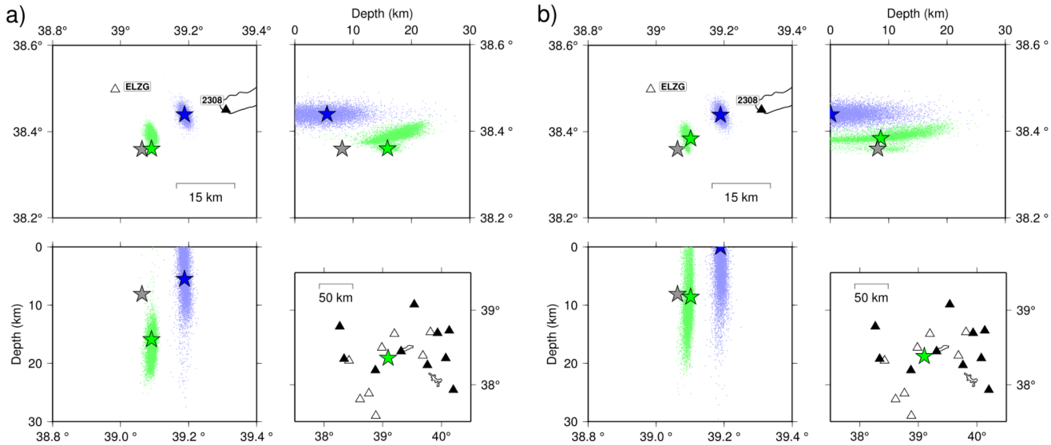

Figure S11. Probabilistic location of the Elazig mainshock. The NonLinLoc code is used (Lomax et al., 2001). Panels a) and b) refer to velocity models VM1 (Acarel et al., 2019) and VM4 (Pasyanos et al., 2004), respectively. In each panel, the map view and the two vertical cross-sections are demonstrated, together with used stations in the bottom-right subpanel (broadband and strong motion stations are shown by the open and filled triangles, respectively). Green and blue stars are the best-fitting first (H) and second (H’) hypocenter, corresponding to the first P (weak) and the second (strong) P’ onset (Figure 1). The equally colored ‘clouds’ indicate their probability density function. The gray star, shown for comparison, is the solution by AFAD.

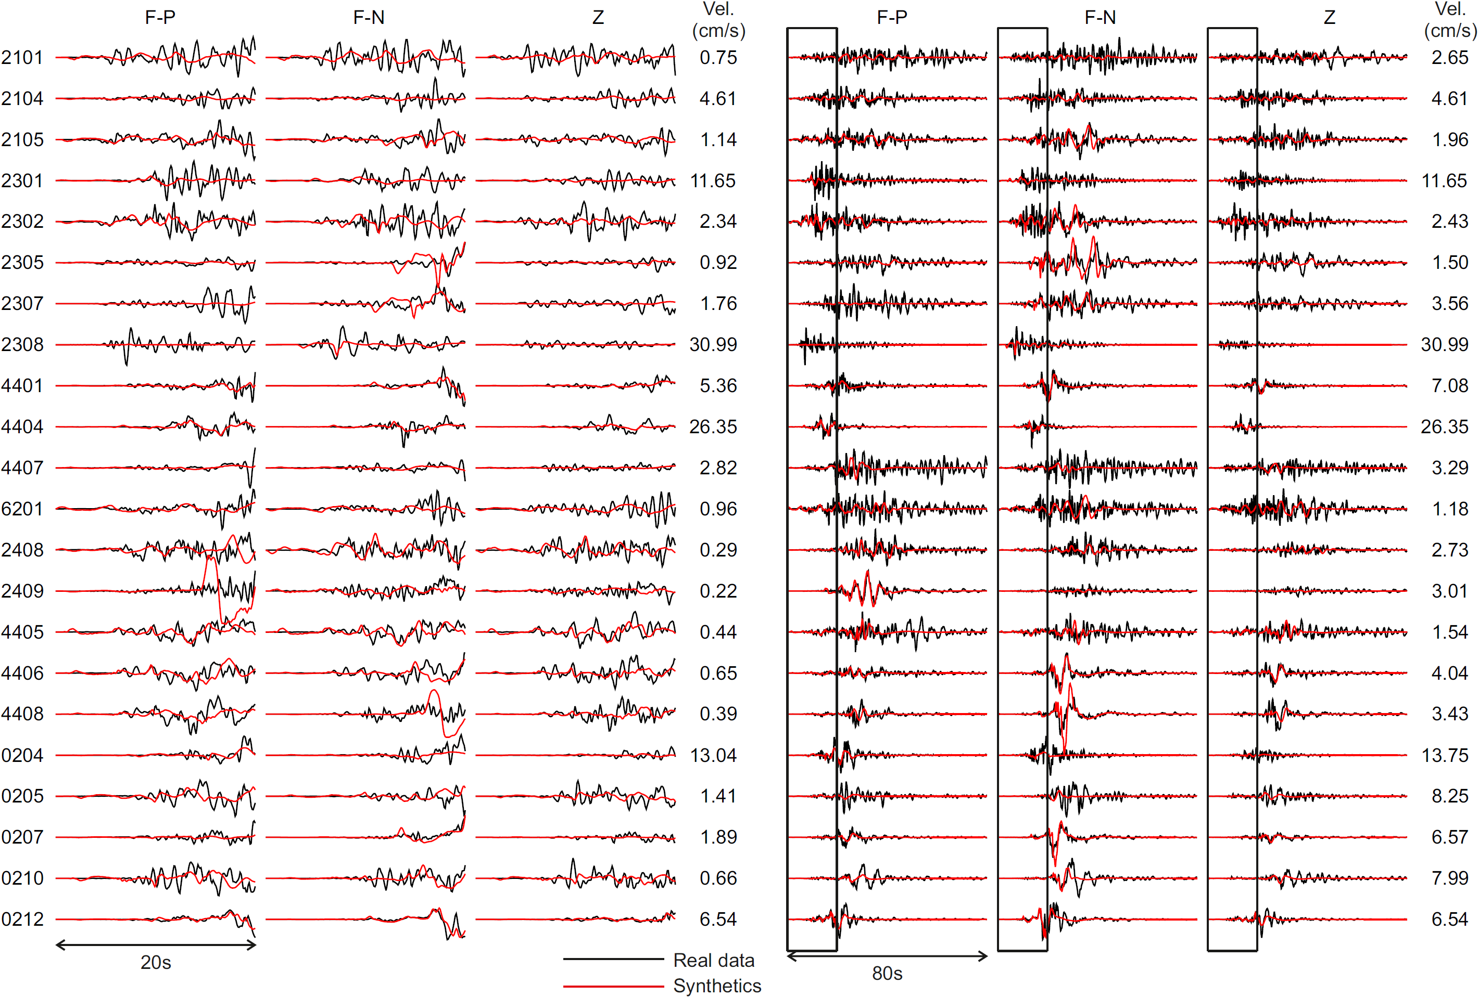

Figure S12. Prediction of ground motions up to 2.5Hz by the MAP dynamic rupture model. Left three columns are zoomed-in beginnings of the full seismograms shown in the right three columns. The waveforms are aligned 1 s before the theoretical P wave arrival for plotting. No additional (station-dependent) time shifts are made. Note that the weak amplitudes between P (clearly emergent from the pre-signal noise in the observed data) and P’ are almost invisible at this scale at most stations. We also point out that the although the dynamic source model is constrained only by low-frequency data and despite we neglect any 3D wave-propagation and site effects, the major characteristics of the observed waveforms are captured by the synthetics. In particular, although the high-frequency (random) oscillations are not modeled at most stations, the timing and amplitudes of the major pulses are fitted well.

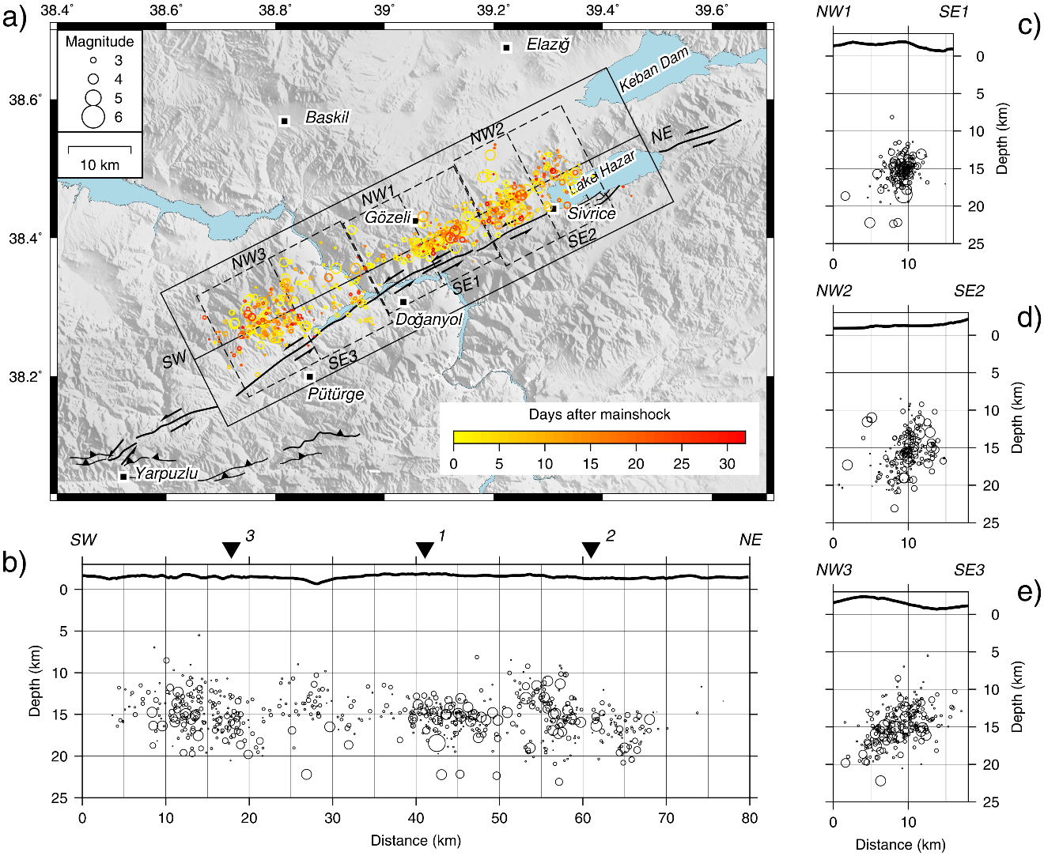

Figure S13. Re-location of the Elazig sequence. a) Map view with the profiles and their swaths used to construct cross-sections. b)-e) Vertical cross-sections along the indicated profiles.

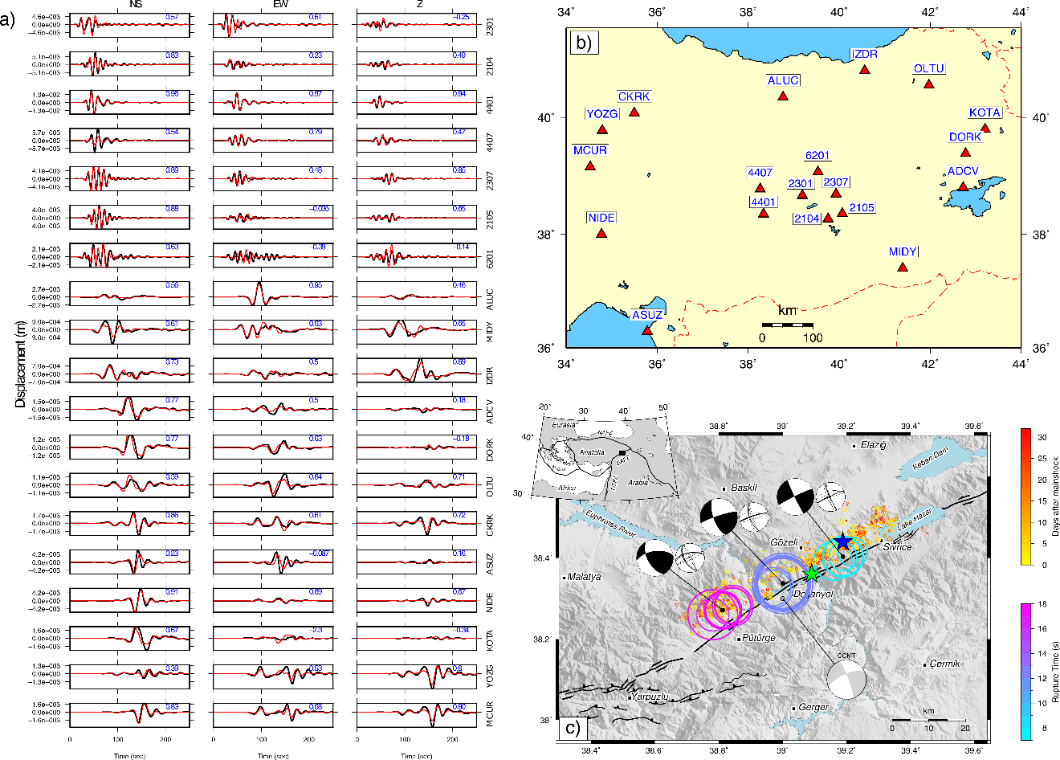

Figure S14. The waveform fit for the 3-point source model based on a joint inversion of the broad-band and strong motion records, MPS-BB-SM. The frequency ranges are 0.01-0.05 Hz and 0.05-0.10 Hz for broadband (BB) and strong motion (SM) stations, respectively; variance reduction VR=0.77. a) The observed and synthetic displacements are shown by black and red lines, respectively. Time t=0 is the origin time. b) Station distribution: SM stations, marked by their numeric codes, are in the central part; other stations BB. c) Multiple-point-source model (same as in Figure 1 of the main text).

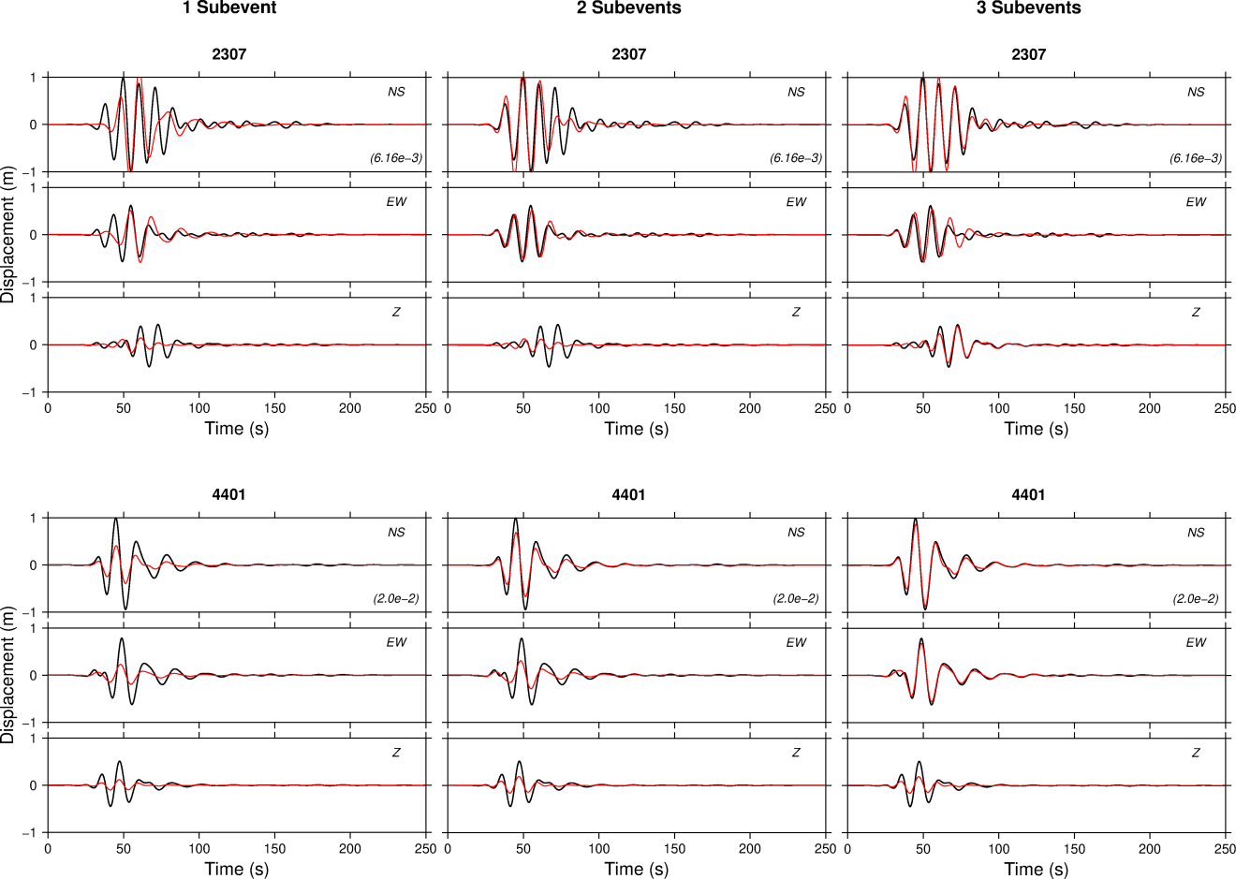

Figure S15. The waveform fit for one, two or three subevents in MPS-BB-SM (from left to right). The strong-motion stations 2307 (top) and 4401 (bottom) are in the backward and forward direction, relative to rupture propagation. Peak values of the observed displacements (in meters) are indicated in the NS-component panel.

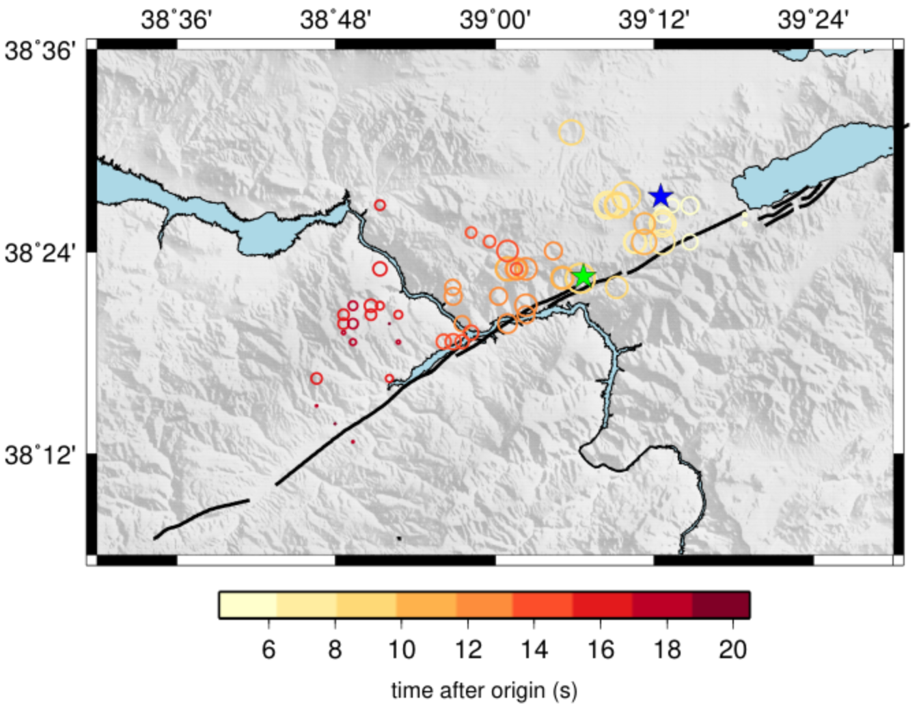

Figure S16. Back-projection of strong-motion waveforms for the 2020 Elazig earthquake. The spatial-temporal evolution of the earthquake source is imaged by the back-projection of strong motion waveforms (Evangelidis & Kao, 2013; Kao & Shan, 2004). Normalized high frequency (HF, 2-8 Hz) S-waveforms from recordings on SM stations within ~100 km epicentral distance are used to scan a predefined 3D source volume over time. This is achieved by stacking the seismic waveforms along predicted travel times for the corresponding seismic phase and source-receiver paths. When sources exist at specific locations and times, large amplitudes are expected at the predicted arrival times in each station, resulting in large brightness values, the so-called bright spots, corresponding to sources of HF radiation. The colored plotted circles represent maximum brightness locations in time, size-scaled proportionally to their values. Hypocenters H and H’ are plotted as green and blue stars, respectively. Almost 5 s after the origin time of hypocenter H, the S-wave HF energy appears NE close to H’. The HF sources show a migration towards the SW along the fault strike. The brightness values tend to concentrate at similar locations as the three MPS subevents (Figure 1). The advantage of the method is that the processing is done without any prior constraints on the geometry, dimension, and size of the source and the known hypocenters resolved by other methods.

